A close up of a sign

Description generated with high confidence

**Press Release** August 2018

**Geneva-based Omkara School of Indian dance premieres a new Bharata Natyam production with an environmental message.**

In collaboration with internationally acclaimed artists from Bangalore (India), students of Omkara will tour JALA – The Dance Of Water in Geneva, Zurich and Bern this October 2018.

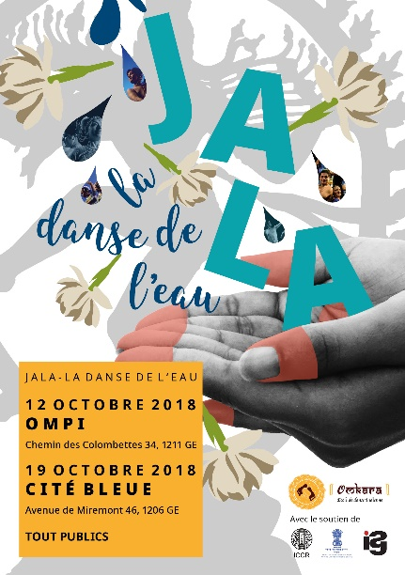 A picture containing sky, outdoor, water, board

Description generated with high confidenceA group of people posing for the camera

Description generated with very high confidence A picture containing sky, water, sport, person

Description generated with high confidence

JALA – The Dance Of Water is a brand new Bharata Natyam production celebrating mankind’s unique, and not always easy, relationship with water.

From religion to industry to everyday life, JALA looks at how water connects us all together through cleverly conceptualised Bharata Natyam sequences, colourful costumes, specially composed music and audio-visual effects.

The end result is the product of months of research, writing, testing, choreographing, learning and perfecting in collaboration with leading musicians, scholars and artists from Bangalore, India.

“JALA is a dedication to my grandmother, and women everywhere who face the hardships brought on by water scarcity, yet do their best for their families day after day with nothing but smiles on their faces. In such parts of the world water is celebrated, revered, conserved – an appreciation that many of us who can access free flowing water so easily forget and don’t think twice about. Every drop counts, and I’m thrilled to be able to convey this message through my art form.” - Sujatha Venkatesh, Artistic Director of Omkara School of Indian Dance.

JALA will tour Switzerland this October 2018 stopping at:   
  
WIPO, Geneva – 12 October 2018  
Cite Bleue, Geneva - 19 October 2018  
Theatre Kaefigturm, Bern – 21 October 2018  
Theatre Ramibhule, Zurich - 26 October 2018

Performing JALA are Omkara School of Indian Dance’s own students alongside internationally acclaimed professionals from Bangalore, India*.

Promoting the sustainable use of water, proceeds from Jala will go Helvetas: Swiss Intercooperation and Nanhi Kali working in water infrastructure and girl education in India and Nepal.

For more information about JALA – The Dance Of Water or Omkara School of Indian Dance visit [www.omkara-dance.com](http://www.omkara-dance.com)/jala.

**PR Contact:**

Divya Venkatesh (English), +44 7942 604 789 – [divyaani@gmail.com](mailto:divyaani@gmail.com)

**- ends –**

**Notes to Editors**

**Tickets and info:**

CH 25 (normal price), CH 20 (AVS), CH 18 (student)  
  
Duration : 1h 30 minutesWIPO, start time 18h – Free, please RSVP to contact@indianassociationgeneva.com before 1 Octobre 2018.

Cité Bleue, start time 18h30 – <https://www.ticketcorner.ch/jala-la-danse-de-leau-tickets-geneve.html?affiliate=TCS&doc=artistPages/tickets&fun=artist&action=tickets&key=2252920$11045873>

Theater Käfigturm, start time 17h - [www.theater-am-kaefigturm.ch](http://www.theater-am-kaefigturm.ch)

Aula der Kantonsschule Rämibühl, start time 17h30 – <https://www.ticketcorner.ch/jala-la-danse-de-leau-tickets-zuerich.html?affiliate=TCS&doc=artistPages/tickets&fun=artist&action=tickets&key=2252920$11045824>

**Omkara School of Indian Dance** has been a centre for learning Bharata Natyam (South Indian classical dance) and promoting Indian culture since 1987.

Home to students of varied nationalities and walks of life, its aim is to foster a deep passion for the art-form while increasing awareness for traditional and cultural Indian arts in and around Geneva.

**Sujatha Venkatesh** is the artistic director of Omkara School Of Indian Dance, and has been teaching, training, performing and choreographing since 1987 in Geneva, her work theatre.

An active artist who regularly tours India and Europe, Sujatha uses her art to help uplift the underprivileged through donations to non-profit organisations and charities, and contribute to movement therapy research through her work with Dr Jacques Arpin, MD in psychiatry and anthropologist.

**\*Performing JALA:**

Sujatha Venkatesh, Saskia Newell, Laetitia Seiffert, Kajani, Divya Venkatesh (from Omkara School of Indian Dance).

Padmini Upadhay, Sathyanarayana Raju, Surya Rao, Madhu Chandra, Srinivas, Deepa Hegde, Nikhita (from Bangalore, India).